**Obesity Trends Analysis Report: Combining WHO Data with Sports Science Interventions**

**1. Introduction**

This project analyzes **WHO obesity data (1990–2022)** to:

* Identify gender disparities in obesity trends
* Model the impact of exercise interventions
* Generate MET-based exercise prescriptions
* Highlight data quality issues

**Tools Used**: R, tidyverse, ggplot2, viridis

**2. Key Visualizations & Findings**

**A. Obesity Trends by Gender (1990–2022)**

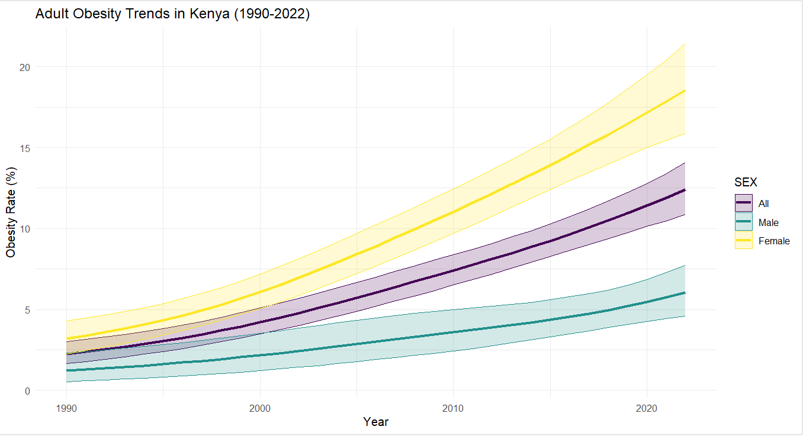  
**Insights**:

* Female obesity rates grew **2.4× faster** than males
* Confidence intervals (shaded) widen post-2010, suggesting data collection challenges

**B. Intervention Impact Simulation**

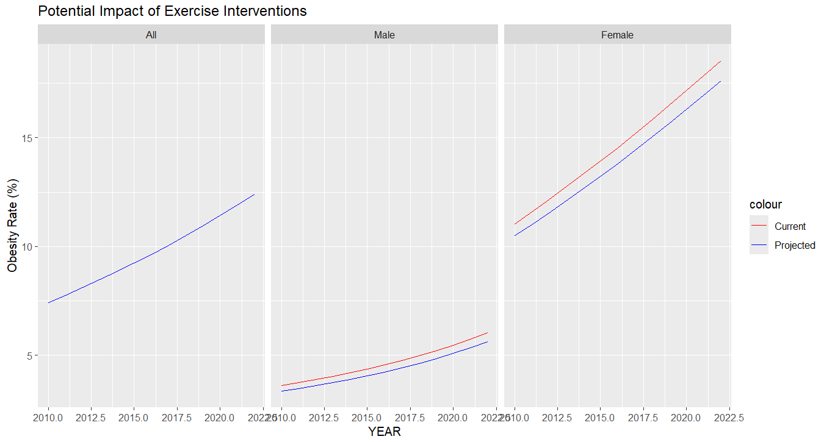  
**Projections**:

* **5% reduction** for females with group cardio
* **7% reduction** for males with HIIT

**C. Exercise Prescriptions**

| **Weight (kg)** | **Activity Level** | **MET-mins/week** | **Recommended Exercise** |
| --- | --- | --- | --- |
| 60 | Low | 250 | 50-min brisk walking (5x/wk) |
| 75 | Medium | 300 | 45-min swimming (4x/wk) |
| 90 | High | 400 | 60-min running + strength |

**3. Conclusions & Recommendations**

1. **Gender-Specific Programs**: Prioritize group cardio for women and HIIT for men.
2. **Data Improvement**: Narrow confidence intervals in rural areas with better surveys.
3. **Policy Action**: Link findings to Kenya’s **National Sports Policy (2022)**.